**MAULANA AZAD NATIONAL INSTITUTE OF TECHNOLOGY BHOPAL**

**DEPARTMENT OF CSE**

Name: Yashwant Patidar

Scholar Number: 191112243

Section: CSE 2

3rd SEM BTech

Subject: Principles of Programming Languages Lab - CSE 219

**Lab Assignment 2**

**Question 1:** WAP to create, initialize, assign and access a pointer variable.

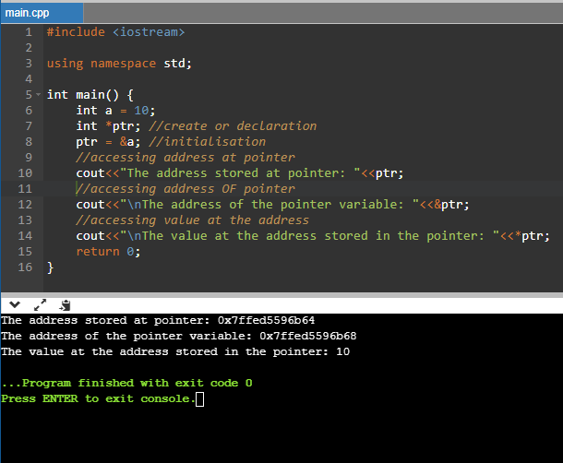

**Question 2:** WAP to swap two numbers using pointers.

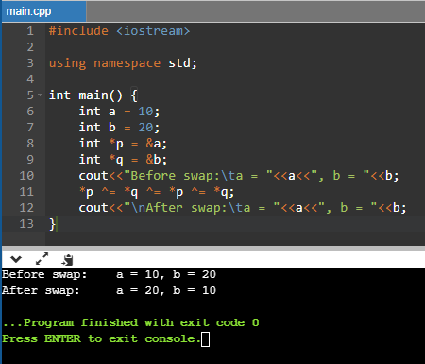

**Question 3:** WAP to count all vowels and consonants in a string using a pointer.

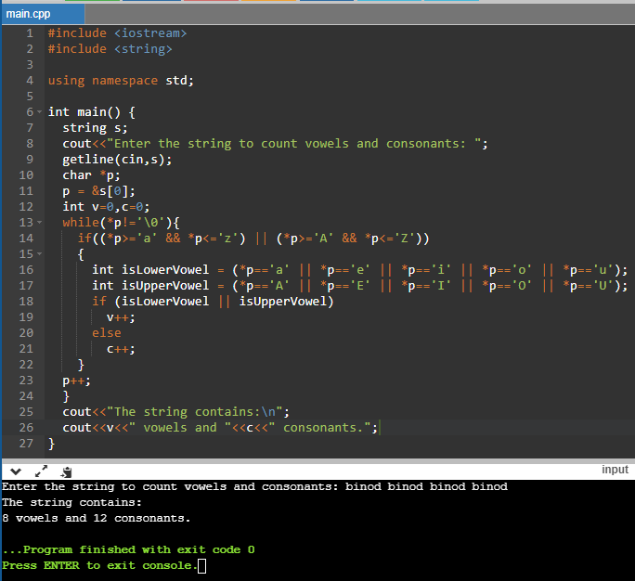

**Question 4:** WAP to read array elements and print with addresses.

